**In-class programming No.4**

heap sort

A school needs to publish scores of an exam. It has 50 classes from No.1 to No.50, and 20 students in each class. You need to sort the average score (accurate to the second decimal place) of the classes using heap-sort in decreasing order.

**Requirements:**

Print the initial and sorted result, as followed:

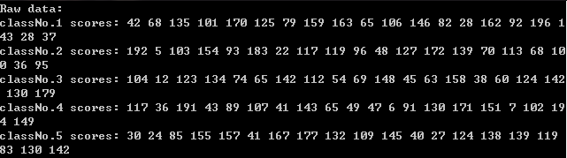

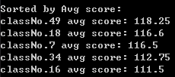



You can finish the code using the sample code, or do it by yourself.

Please print your name at the end of your program.

cout << “your name”;

Send the source code and result to the TA’s email after class.

The first 23 students can obtain 1 point.